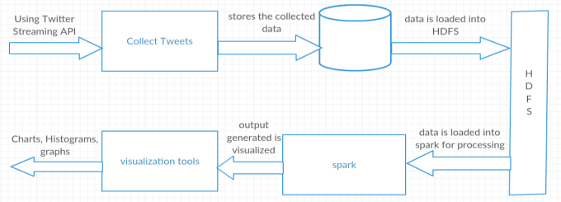

* Collecting tweets from twitter.
* Collecting hashtags and URLs using hadoop.
* Analysing the tweets using spark.

**Methods**

Twitter is a social media platform on which people interact with each other through “tweets”. These tweets can be used for performing different analytical queries and to develop interesting visualizations.

**Introduction**

**Architecture**

**TWITTER DATA ANALYSIS**

**VISUALIZATIONS**

**Popular Languages**

**Popular Technologies**

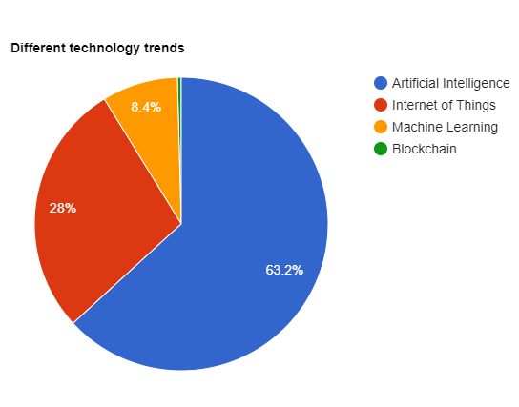 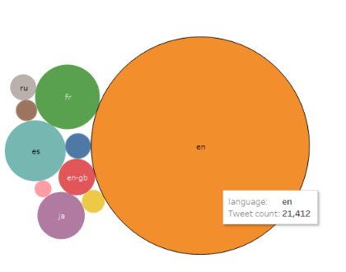

**Different U.S states trend**

**Monthly tweets on technology**

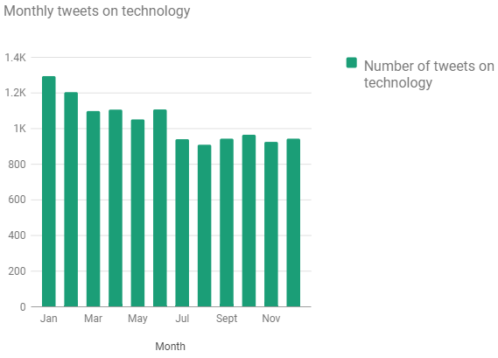 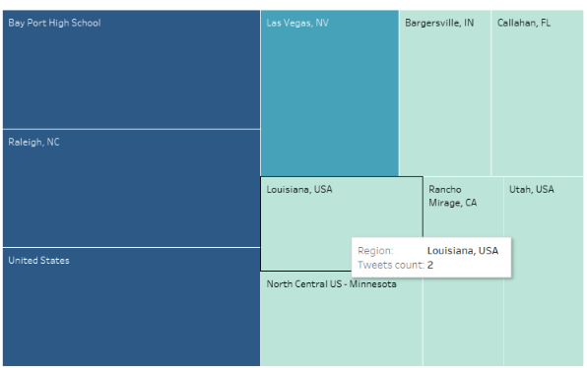

**Popular companies trend on technology**

**Technology languages trend**

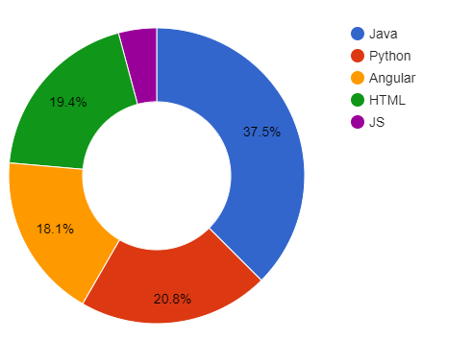 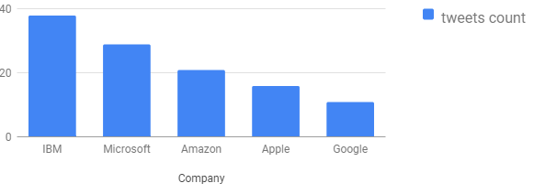

**Day-wise tweets on technology**

**Users who got most re-tweets**

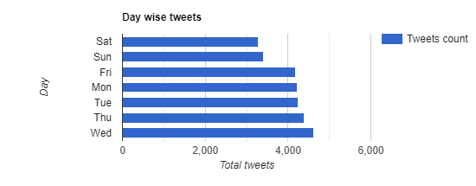 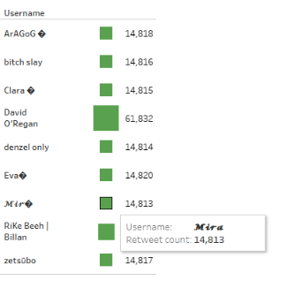

**Users with more friends and followers count**

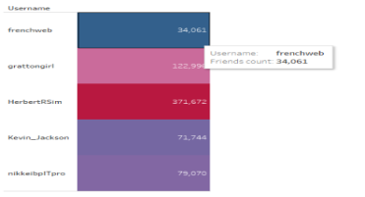 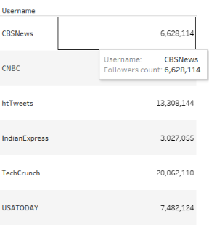  

**Technologies Used**

  